Ideation Phase
Empathize & Discover — Empathy Map Canvas
Student Name | Yuvasri Malla
Project Name | Automated Licensed Software Installation Request Management
Maximum Marks | 4 Marks

Empathy Map Canvas
Dimension | Employee / End User Perspective
Says | I need a simple and quick way to request licensed software through one centralized ServiceNow catalog.
Thinks | I want only relevant software options, clear license information, and a guided request form that tells me what details are required.
Does | Opens the Service Portal, selects the Licensed Software Request catalog item, chooses the software, enters the required details, and submits the request.
Feels | Wants a fast, reliable, secure, and transparent software request experience with clear approval and installation status.
Pain Points | Incomplete request information, unclear software choices, approval delays, manual license checks, delayed installation, and limited request-status visibility.
Needs /  Goals | Guided request submission, complete information capture, license availability validation, automated approvals and fulfillment tasks, timely notifications, and end-to-end status tracking.
Licensed Software Installation — Empathy Map
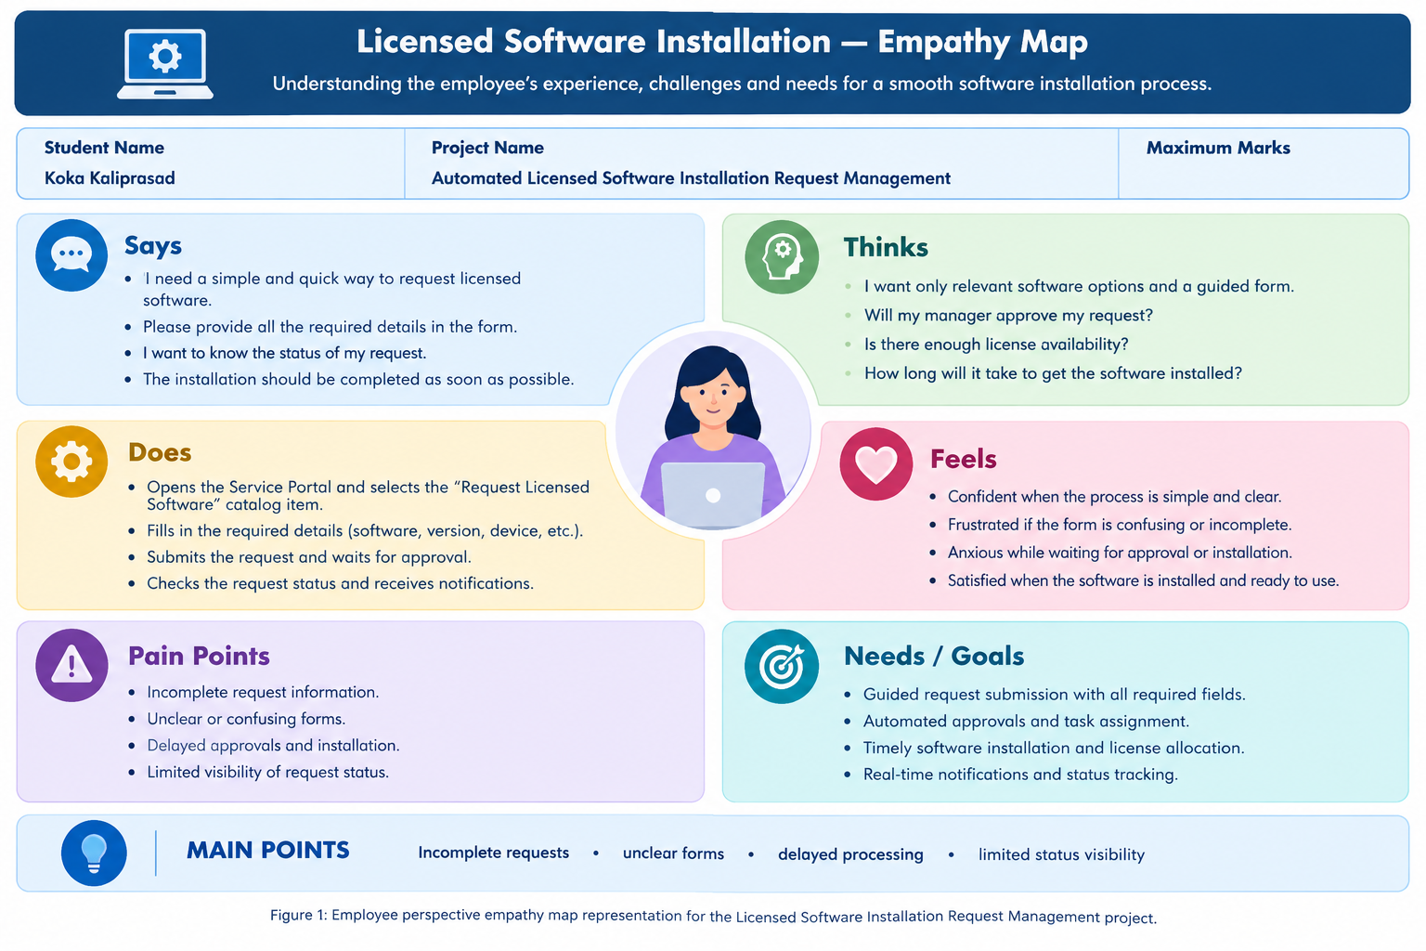
MAIN POINTS
Incomplete requests • unclear software choices • approval delays • manual license checks • delayed installation • limited status visibility
Figure 1: Employee perspective empathy map representation for the Automated Licensed Software Installation Request Management project.

